|  |
| --- |
| Functional test cases -  H7 |
| DMS H7 |

|  |
| --- |
| Test Scenarios – H7  May 2021 |
|  |

# Document version

|  |
| --- |
|  |
| Document version:   |  |  |  |  | | --- | --- | --- | --- | | Version nr. | Dato | Created by | Changes | | 0.1 | 25/01/21 | Katrine Gawronski Frederiksen | - | | 0.2 | 23/02/21 | Katrine Gawronski Frederiksen | - | | 0.3 | 08-03-2021 | Bjarke Runz Jensen | Removed section on Control notification.  Updated references to Notification codes. | | 0.4 | 11-05-2021 | Jacob Rindom Bertelsen | Reworked diagrams, formatting, | | 0.5 | 24-08-2021 | Emma Hagerup | Updated test data and descriptions. | |  |  |  |  | |  |  |  |  | |  |  |  |  | |

Table of Content

1 Document version 1

2 Introduction 3

2.1 Test data and preconditions 3

2.2 Process flow 4

2.3 Test Scenarios 4

3 Detailed test scenarios 5

3.1 Scenario 1: Create a H7 IMA declaration 5

3.2 Scenario 2: Create a H7 IMD declaration 6

3.3 Scenario 3: Create a H7 declaration which is rejected 6

# Introduction

The purpose of this test phase is for the economic operator (EO) to submit an import declaration via the H7 format (reduced data set) through Axway. H7 is used to import goods from countries outside the European Union, with the purpose of free circulation and free consumption in the EU. The H7 can be used if the goods live up to the following criteria[1]:

* 1. The total amount of goods on the declaration do not have a value over 1150,00 DKK
  2. The goods are imported by a private person to another private person (gift) with a maximum value of 360,00 DKK

In the two above mentioned cases there will only be charged import VAT, because the goods are of low value and gifts are duty free. If the value exceeds the value limit the goods cannot be imported via a H7 declaration, and another data set is required e.g. a H1.

## Test data and preconditions

To be able to do execute the functional test cases for H7, the EO must have established a connection to the DMS test system, following the Connectivity Guide. This must be done using the following services:

* DMS.Import.Declaration.Submit

To endpoint:

* [https://secureftpgatewaytest.skat.dk:6384/exchange/CVR_<CVR>_UID_<UID](https://secureftpgatewaytest.skat.dk:6384/exchange/CVR_%3cCVR%3e_UID_%3cUID)>

This document differentiates between a pre-lodged H7 declaration and a standard H7   
declaration. Where a pre-lodged H7 declaration refers to a declaration where the EO sends a declaration containing information about a good/goods before the goods have arrived in Denmark. A standard declaration refers to a declaration which is made when the goods have arrived in Denmark.

A pre-lodged declaration will from now on be referred to as an IMD.

A standard declaration will from not on be referred to as an IMA.

## Process flow

The process flow for submitting the different H7 declarations in Figure 1 and Figure 2 below.

Process flow for an IMA

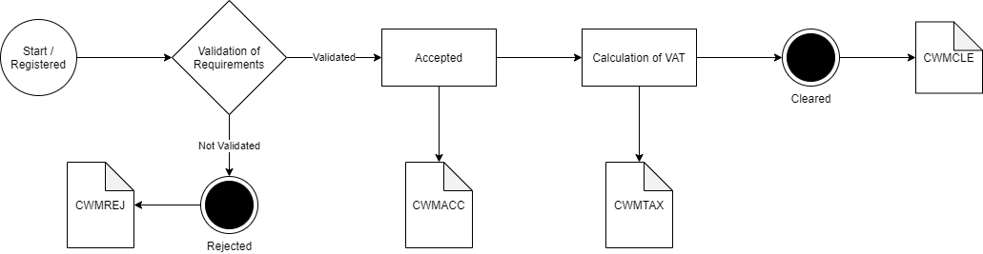

Figure 1 – IMA

Process flow for an IMD

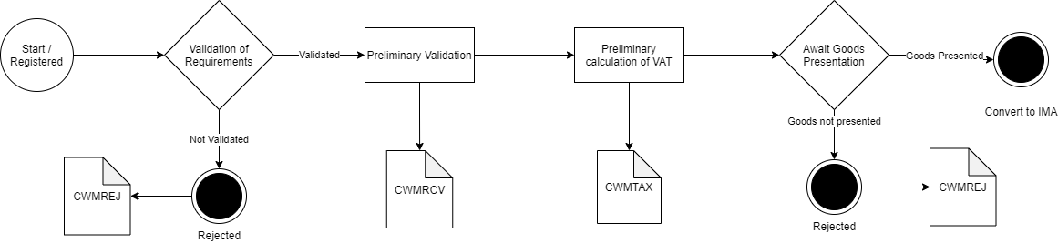

Figure 2 – IMD

## Test Scenarios

To complete the functional onboarding phase two, the OE must deliver confirmation of passed test-cases for each test scenarios:

|  |  |  |
| --- | --- | --- |
| **Test no** | **Test Scenario** | **Passed** |
| **1** | Create a successful H7 declaration IMA | ☐ |
| **2** | Create a successful H7 declaration IMD | ☐ |
| **3** | Create a H7 declaration which is rejected | ☐ |

# Detailed test scenarios

The following sections will describe the aim of the specific test scenarios and it will provide the desired results of the test. It should be noted that there can be changes in the notifications provided by the DMS solution, because the solution is still in development. If at a later point more notifications will be added, the EO will be informed about this and the EO will be requested to complete the test again.

## Scenario 1: Create a H7 IMA declaration

The aim of scenario 1 is to test if the EO can submit a successful H7 IMA declaration.

To be able to do this successfully the H7 declaration has to be filled out correctly in coherence to EUCDM regulations and in coherence with the requirements specified in the H7-XSD[2] provided by UFST.

If a H7 IMA declaration is filled out correctly the EO should obtain following notifications:

* Notification of acceptance (CWMACC)
* Notification of VAT (CWMTAX)
* Notification of release (CWMCLE)

**Success**The test is completed successfully if the EO has obtained all the above-mentioned notifications.

**Test data example**

The following test data should be used:

* Submit initial H7 IMA declaration: *IMA.xml* (remember to fill in LRN)
* Pull notification to see the notifications.

## Scenario 2: Create a H7 IMD declaration

Test scenario 2 will test if the EO can submit an IMD declaration. To be able to do this successfully the H7 declaration has to be filled out correctly in coherence to EUCDM regulations and in coherence with the requirements specified in the XSD provided by UFST.

The aim of scenario 2 is for the EO to ensure they can receive the notifications connected to an IMD declaration before presentation of goods, namely;

* Notification preliminary VAT (CWMTAX)
* Notification of Receival (CWMRCV)

If a H7 IMD declaration is filled out correctly the EO should obtain the notifications automatically, except presentation notification status. To trigger presentation notification status the EO has to provide a presentation notification stating that the goods have arrived in Denmark. When the goods have been presented the IMD declaration will turn into an IMA declaration which will result in the last to notifications (Notification of VAT and Notification of release).

**Success**The test is completed successfully if the EO has obtained all the above-mentioned notifications.

**Test data example:**

The following test data should be used:

* Submit initial H7 declaration: *IMD.xml* (remember to fill in LRN)
* In this case, since the presentation notification is manually handled by a customs officer you should contact you assigned onboarding contact person when the request has been successfully sent:
  + Write an email to your onboarding contact person with the following information:
    - Which application was sent (in this case: a presentation notification for an IMD/pre-lodged declaration)
    - MRN
    - LRN

Your onboarding contact person will then grant the presentation notification application which fulfills Scenario 2.

* Pull notification to see the notifications.

## Scenario 3: Create a H7 declaration which is rejected

The aim of test scenario 3 is to ensure that the EO can obtain a notification of rejection.

It has been chosen for test purposes that the notification of rejection should be based on the declaration not living up to the value demands, meaning that the goods item value surpasses 1.150 DKK/150 EUR.

To trig this notification of rejection, the EO should create an H7 declaration where the value of the goods items is above 1.150 DKK/200 EUR:

<ns2:CustomsValueAmount currencyID= “DKK”>1160.00</ns2:CustomsValueAmount>

**Success**The test is completed successfully if the EO has obtained a notification of rejection.

**Test data example:**

The following test data should be used:

* Submit initial H7 declaration: *IMA_rejected.xml* (remember to fill in LRN)
* Pull notifications to see the notification of rejection.

#Decorative

|  |  |  |  |
| --- | --- | --- | --- |
|  | www.ufst.dk  ISBN |  | Udviklings- og Forenklings- styrelsen er en del af  Skatteforvaltningen |

1. In some cases these criterias can be combinded
2. https://github.com/skat/dms-public/releases